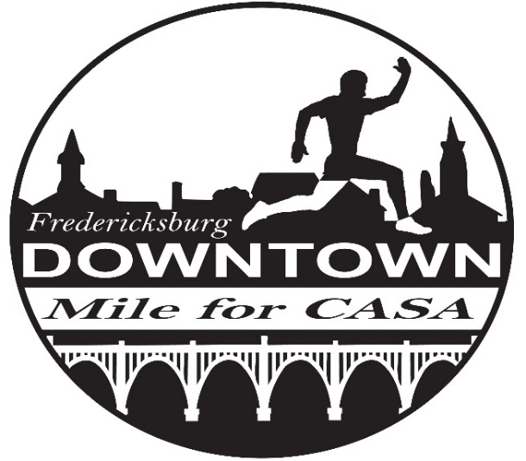
Thank you for sponsoring the Downtown Mile for CASA! The September 10th, 2022 Downtown Mile for CASA will be a live one-mile race with a virtual option sponsored by the Fredericksburg Area Running Club. This event will benefit Rappahannock CASA, which advocates for abused and neglected children in the Fredericksburg area. Please learn about CASA and their mission at http://www.rappahannockcasa.com/

Please complete the form below to become a sponsor of the 2022 Downtown Mile for CASA.

Sponsor’s name: ________________________________________________________________

Contact person’s name: _________________________________________________________

Contact phone #: _______________ Contact email: ________________________________

Sponsorship level (Please check one.):

- Presenting Sponsor (Title Sponsor) ($2,500):
  - The presenting sponsor will have exclusive naming right. (The Downtown Mile for CASA presented by…)
  - A presenting sponsor banner will be displayed at the start/finish line.
  - Presenting sponsor name and logo advertised on The Downtown Mile for CASA race registration site with a link to your website.
  - Sponsor can provide banners to be displayed near the finish line
  - Sponsor logo and presenting title will be displayed on the front of race shirts
  - Sponsor is provided booth space at the finish line area
  - Marketing materials (provided by the sponsor) will be placed inside each race packet
  - Sponsor listed on all printed ads for the race
  - Social media recognition through FARC, Downtown Mile for CASA and Rappahannock CASA profiles.

- Platinum (Heat Sponsor) ($1,000):
  - Heat Sponsors will be recognized at the beginning of their heat during the race.
  - Sponsor name, logo and website link placed on The Downtown Mile for CASA race registration site
  - Sponsors are welcome to provide a banner to be displayed near the finish line
  - Sponsor logo will be displayed on the back of race shirts
  - Space provided at the finish line for table/booth display
  - Marketing materials (provided by the sponsor) will be placed inside each race packet
  - Sponsor listed on all printed ads for the race
  - Social media recognition through FARC, Downtown Mile for CASA and Rappahannock CASA profiles.

- Award Sponsor (Prize Money Sponsor) ($1,000):
  - Award Sponsor will be recognized at the beginning and end of each heat during the race.
  - Award Sponsor will present all prize money awards during the event.
  - Sponsor name, logo and website link placed on The Downtown Mile for CASA race registration site
  - Sponsor is welcome to provide a banner to be displayed near the finish line
  - Sponsor logo will be displayed on the back of race shirts
  - Space provided at the finish line for table/booth display
  - Marketing materials (provided by the sponsor) will be placed inside each race packet
  - Sponsor listed on all printed ads for the race
  - Social media recognition through FARC, Downtown Mile for CASA and Rappahannock CASA profiles.

- Gold ($500):
  - Sponsor logo will be displayed on the back of race shirts
  - Sponsor name, logo and website link placed on The Downtown Mile for CASA race registration site
  - Marketing materials (provided by the sponsor) will be placed inside each race packet
  - Social media recognition through FARC, Downtown Mile for CASA and Rappahannock CASA profiles

- Silver ($250-$499):
  - Marketing materials (provided by the sponsor) will be placed inside each race packet
  - Social media recognition through FARC, Downtown Mile for CASA and Rappahannock CASA profiles.

Note: Sponsorship can be made until race day, however logos must be received by August 20th to be placed on race t-shirts and bibs. Please email your company logo to dtmile4casa@runfarc.com (please put “Downtown Mile logo” in the subject line).
Please mail this form and your sponsorship check to the Fredericksburg Area Running Club (FARC) at P.O. Box 3653, Fredericksburg, VA 22402. Donations to FARC, a 501(c)(3) club, are tax-deductible. While FARC organizes the race, CASA will receive 100 percent of race proceeds to assist with their mission.
Race Website- https://runsignup.com/Race/VA/Fredericksburg/DowntownMileforCASA

Questions? Email CASA at rappcasa@gmail.com or race organizers at dtmile4casa@runfarc.com.

